The Grey Matter of Securing Android Applications

*Version 1.0*

*6th April, 2018*

*A whitepaper to help developers code a secure Android application by leveraging the security features provided by Google*

*Whitepaper*

*By*

***Shiv Sahni***

*Senior Security Analyst*

*Lucideus Technologies*

[*shiv.s@lucideustech.com*](mailto:shiv.s@lucideustech.com)

[**](http://lucideus.com/)

[**](https://www.linkedin.com/in/shivsahni/)[**](https://security.stackexchange.com/users/159736/shiv-sahni)[**](https://twitter.com/shiv__sahni)

Table of Contents

**Abstract** **5**

**Introduction** **7**

Android Software Stack 7

APK: Android Application Package 8

APK Internals 9

Android Application Components 10

**Background/Problem Statement** **12**

**Security Features By Google** **13**

Application Sandbox 13

Notes for Developers 14

World Accessible Files 14

Rooted Devices 14

Android Permission Model 16

Permission Protection Levels 16

Permission Groups 16

Correlation of Application Sandbox and Android Permission Model 17

Notes for Developers 18

Excessive Permissions 18

Securing Application Components Using Permissions 18

IPC: Inter Process Communication 19

Intents 19

Explicit Intents 19

Implicit Intents 19

Intent Filters 19

Notes for Developers 20

Insecure IPC Mechanisms 20

Insecure Android Broadcasts 20

Insecure Implementation of Pending Intents 21

Exploit Mitigation Techniques 23

ASLR 23

Data Execution Prevention 23

Protecting Stack 24

Notes for Developers 24

Leveraging Underlying Exploit Mitigation Techniques 24

Usage of Banned Functions and Vulnerable Libraries 25

Application Signing 26

Digital Signature 26

Application Signing Process 29

Notes for Developers 30

Insecure Signing Scheme 30

Insecure Signing Algorithms 30

Android Keystores 31

Keystore 31

Android Keystore 31

Hardware Backed Keystore 32

TEE:Trusted Execution Environment 32

Keystore Entries 33

SafteyNet: Developers Friend 35

SafteyNet APIs 35

SafetyNet Attestation API 35

Compatibility Test Suite Results 35

Basic Integrity Checks 36

Application Integrity Checks 36

Architecture 36

SafetyNet Verify Apps API 38

SafetyNet reCAPTCHA API 39

SafetyNet Safe Browsing API 39

Notes for Developers 40

Lack of Rate Limiters 40

Insecure Implementation of Attestation API 41

**Some Other Security Practices** **42**

Secure Crypto Implementation 42

Reducing Unnecessary Attack Surface 42

Avoid Usage of Insecure and Custom Cryptographic Algorithms 42

It is recommended that following cryptographic algorithms should be used: 43

Avoid Insecure Key Derivation Mechanisms 43

Secure Pseudo Random Number Generation 44

Securing Android Webviews 45

Webview Hardening 45

Preventing Excess Authorization 46

OWASP Dependency Check 47

10 Things To Check Before Publishing The Application 48

**Conclusion** **49**

**About Author** **50**

Lucideus Technologies: The Author’s Company 50

About Technical Editor and Reviewer 50

**Acknowledgements** **52**

References 52

Additional Resources 55

# Abstract

According to Gartner’s research Google's Android is the leading smartphone operating system in the world [1] (Exhibit 1). One of the significant reasons for the popularity of the Android platform is indeed its openness. The popularity of Android platform has lead to a massive increase in third-party application development in Google’s Play Store. According to Statista, the number of available apps in the Google Play Store was most recently placed at 3.3 million apps in September 2017, after surpassing 1 million apps in July 2013[2].

The Android applications nowadays, are not only used for entertainment purposes but also for making financial transactions, medical assistance etc. which means that there is a flow of sensitive data on the underlying platform which has a significant requirement of security.

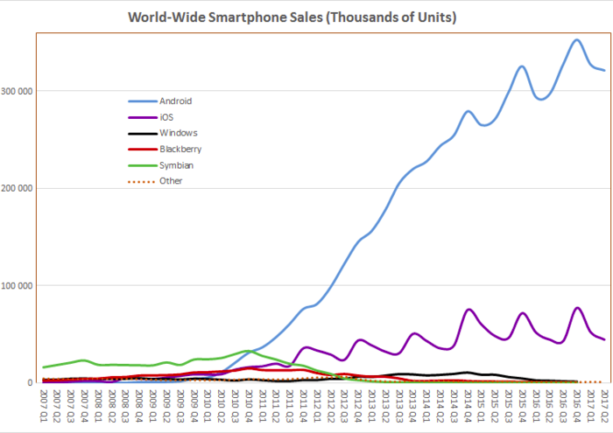

Exhibit 1

*Source:* [*Gartner*](https://www.gartner.com/newsroom/id/3725117)*[1]*

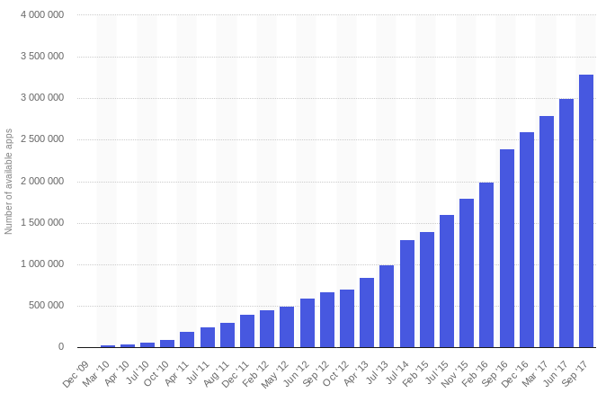

Exhibit 2

*Source:* [*Statista*](https://www.statista.com/statistics/266210/number-of-available-applications-in-the-google-play-store/)*[2]*

The paper discusses the security features that are provided by Google and how the same can be leveraged by developers to make the applications secure and robust. The security features provided by Google often aren't implemented or are implemented in an improper way. This makes the application vulnerable to the security issues. The paper will enable developers to understand the security features and will also highlight the benefits of implementing the same.

# 

# 

# Introduction

Android is a open source Linux based software stack that is developed by Google. It was initially developed by Android Inc. and was later bought by Google. It is used by many commonly used devices such as smartphones, tablets, wearables, smart TVs etc.

## Android Software Stack

The Android software stack is shown in Exhibit 3 and the same is explained below:

# 

Exhibit 3

*Insides of Android Platform*[3]

**Linux Kernel:** Android platform is built on the top of a robust Linux kernel. The Linux kernel itself provides the advantage ofunderlying security features such as process isolation, user-based permission model etc.[4] As shown in Exhibit 3 this layer provides all the essential hardware drivers like camera, keypad, display etc.

As of 2017, Linux kernel v3.18 or v4.4 is used by Android devices. However, The actual kernel depends on the individual device.

**Hardware Abstraction Layer:** Hardware Abstraction Layer gives the Android Platform freedom to implement any device specifications and drivers by providing the standard method for creating software hooks between the Android platform stack and your hardware.

**Android Runtime:** It consist of core libraries and Dalvik Virtual Machine(DVM). The core libraries are the Java based libraries that provide the primary APIs for developers to write Android applications.

Each Android application runs as a different process on the Linux kernel in its own Virtual machine. Just like JVM, DVM is also a virtual machine but the latter is designed by Google specifically for mobile platforms. For Android version 5.0 (API level 21) or higher, the successor of DVM was introduced viz. ART(Android Runtime) which had the following performance improvements over conventional DVM:

* Compilation: Compiles the application only once using AOT(Ahead of Time) approach.
* Power Consumption: Reduces power consumption.
* Garbage Collection: Optimizes garbage collection (GC).

**Native Libraries:** The core Java based libraries can be considered as the java *wrappers* around the C/C++(Native) libraries. The platform also allows developers to use C or C++ code to build Android applications using native libraries in the native code through Android NDK.

**Application Framework:** The Application Framework is a set of services that collectively form the environment in which Android applications run and are managed. It provides high-level services to the applications through Java classes. Application developers use these high-level services using Java APIs.

**Applications:** Applications are present at the top of the Android software stack. It consists of both the native system applications and the third party applications installed by the user.

## APK: Android Application Package

APK is an acronym used for Android Package Kit. It is a software package that can be installed on Android devices. The software package uses .apk extension. An APK is an archive i.e. a signed zip file that contains the application’s code, resources etc.

Exhibit 4 shows how Android application compilation and execution is different from a java application.

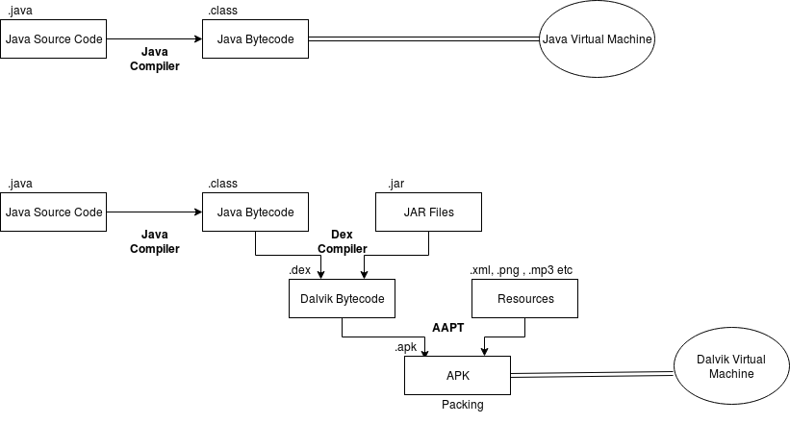

Exhibit 4

*Compilation and Execution of Android Applications*

### APK Internals

APK is basically a signed zip archive that contains the application code, resources, signing certificate etc. On unzipping the APK file we can get the following:

* AndroidManifest.xml: The manifest file describes the essential information about the application. It defines the key attributes of the application such as application components, permission requirements, target and min API version, application icon, package name etc.
* META-INF: The META-INF contains the following:
  + MANIFEST.MF: It is the manifest file and it contains the hashes corresponding to application resources.
  + CERT.SF: It is the signature file that is created after the application is signed. It contains the list of resources and the hash value of each resource corresponding to its entry in the manifest file.
  + CERT.RSA: It is the signature block file. The signature file is a signed file and the signature of the same is placed in signature block file. It also contains the certificate and its metadata.
* assets: It contains the applications assets(HTML/JS Files, pictures etc.) The resources in assets folder can be accessed by Java code using AssetManager.
* classes.dex: This contains the Dalvik bytecode. All the Java code is compiled into Dalvik bytecode and is executed by the DVM.
* lib: It contains libraries that are part of the Android application. The lib directory contains all the libraries that an application may refer to during its execution and which is not a part of the Android SDK.
* res: The res directory contains all the application resources that are not compiled in resources.arsc.
* Resources.arsc: It is a file that contains all the pre-compiled resources.

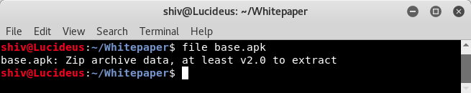

Exhibit 5

*File type of APK*

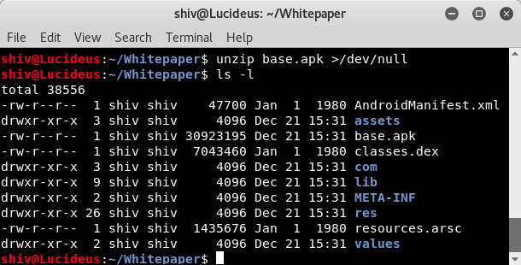

Exhibit 6

*Contents of an APK file*

### Android Application Components

Android application components are high level building blocks of an Android application. Each Android application component is an entry point through which a user or system can interact.

These components are well described in AndroidManifest.xml

The main Android application components are:

* **Activity:** An activity can be considered as a *screen*. It is an application component that has a user interface. A user can interact with the application through activities. The activity handles user interaction. Any Android application usually has one or more activities.
* **Service:** A service is an application component that usually performs long running tasks in the background. Unlike activities, a service lacks a user interface.
* **Broadcast Receiver:** A broadcast receiver listens to system wide broadcast announcements. Like services, broadcast receivers lacks a user interface but the former is meant for long running tasks.
* **Content Provider:** A content provider is an application component that is used to store and share data efficiently. The data can be stored in the file system, SQLite database etc.

**Intents**

An intent is an asynchronous messaging object that allows communication between application components. It can be used for communication between application components of same or different applications. It can be used to start an activity, service or for delivering broadcasts.

# 

Exhibit 7

*Intent to invoke an application component*

# Background/Problem Statement

Android is built on the top of the secure and robust Linux kernel. The platform itself is considered to be secure due to multiple reasons few of them being its openness, regular updates for security enhancements and programs like [ASRP](https://www.google.com/about/appsecurity/android-rewards/)[5](Android Security Reward Programs) that attracts security researchers to build the secure platform.

In addition to making the platform secure, Google also helps developers build secure applications by providing features like [SafteyNet APIs](https://developer.android.com/training/safetynet/index.html)[6] which helps them to add security to their applications and programs like [ASI](https://developer.android.com/google/play/asi.html)[7](App Security Improvement) that scans applications against 26 odd vulnerabilities and notifies developers to remediate the issues.

In spite of having security features like SafteyNet, programs like ASI, and the underlying robust platform the entire ecosystem can only be made secure if the applications are built considering security in SDLC(Software Development Life Cycle). The developers must be aware of using the security features properly. For instance: Using encryption for handling sensitive data will only solve the problem if it is implemented in a proper way by using secure algorithms, secure key management etc.

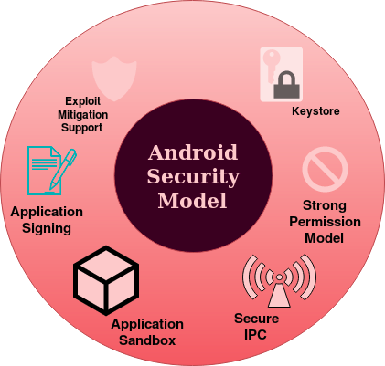

Exhibit 8

*Android Security Model*

# Security Features By Google

## Application Sandbox

Android is built on top of a secure and robust multi-user Linux operating system. The security features of Linux operating system are thus an integral part of the Android platform. For instance, every user in a linux operating system is identified by a unique user ID(UID) and user’s resources are also isolated from each other.

Android takes advantage of the underlying Linux kernel to achieve the concept of *Application Sandbox*. An application installed in an Android device is assigned a unique app ID and each application is considered as a user of the underlying Linux OS. Also each user is allotted a private directory*(/data/data/<package-name>*) which is the local data storage directory of the application.

Application are sandboxed both at process level and at storage level since each application executes as a dedicated process and each application has its own private storage that can not be accessed by any other application on the system.

*Note:* UIDs are statically defined in [android_filesystem_config.h](https://android.googlesource.com/platform/system/core/+/master/libcutils/include/private/android_filesystem_config.h)[8] header file. For example, UID for root is 0. Also, UID 1000-9999 are reserved for system processes. The UID for user application is from *FIRST_APPLICATION_UID* to *LAST_APPLICATION_UID* (10000-99999)

The UID is represented as *uY_aXXX* where xxx is an offset from FIRST_APPLICATION_UID.

For Example: Exhibit 9 shows the results of the *ps* command for user installed application *Effort On The Go* where the package name *ebu.lucideus.com.effortonthego* is same as that of process name. The user id is *u0_a167* which is equivalent to *10167* (10,000+offset_167). Exhibit 10 shows the data directory for the application.

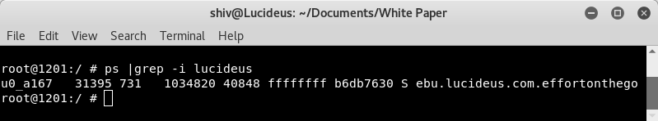

Exhibit 9

*Application Sandbox in Android Platform*

## 

Exhibit 10

*Application Sandbox in Android Platform*

### Notes for Developers

#### World Accessible Files

By default, the files created in the application sandbox are not accessible to other applications installed on the device. The flags like [*MODE_WORLD_READABLE*](https://developer.android.com/reference/android/content/Context.html#MODE_WORLD_READABLE) [9]and [*MODE_WORLD_WRITABLE*](https://developer.android.com/reference/android/content/Context.html#MODE_WORLD_WRITEABLE) [10] allows developers to create world readable and writable files respectively. The flags can be used for IPC(Inter Process Communication) through system files.

These flags were deprecated in API level 17 and the usage of same for application targeting API level 17 or below is strongly discouraged. Android provides much better IPC mechanisms and it is recommended that developers must use them instead of conventional world accessible files. Explicitly specifying insecure file permissions such as *0666*,*0777*, *0664* through syscalls or chmod binary is also strongly discouraged.

The best practice recommendation is to explicitly specify the secure file permissions instead of relying on system’s umask. Since the Android application sandbox could collapse due to misconfiguration and exploitation.

For Example:

Creating File:

*FileOutputStream secureFile=openFileOutput(“SecretFile”, Context.MODE_PRIVATE);*

Creating Folder:

*File secureDirectory=getDir(“SecretDir”,Context.MODE_PRIVATE);*

#### Rooted Devices

Rooting an Android device allows a user to run any application as *root* user. Android is built on the top of Linux kernel and rooting allows a user to give administrative privileges to any application. This collapses the application sandbox, since a root user can run any process with any user ID and can also access private data of any application. Rooting a device circumvents all the security measures of the operating system.

From developer’s point of view, a rooted device can impact the security of the application since it allows any malicious application installed on the rooted device to access the application’s sandbox. It also allows an attacker to perform the runtime analysis of the application where the application could perform unintended actions when the runtime behaviour of the application is modified.

For the applications that involve the flow of sensitive data, it is recommended that the developers must detect and prevent the access from a rooted device. Although there is no sure-shot solution for proper root detection since root cloakers (Ex. [Magisk](https://forum.xda-developers.com/apps/magisk) [11]) work with administrative privileges and root detection can be bypassed but the checks indeed increases the attack complexity thus reducing the overall risk. Developers can use [SafteyNet Attestation API](https://developer.android.com/training/safetynet/attestation.html), the same being described in the later section.

## 

## 

## Android Permission Model

Application sandboxing allows Android applications to only access the files that resides in its sandbox and world accessible files. This limits the scope and functionality of the applications and in order to prevent this Android permission model was designed. In order to provide richer functionalities the model allows applications to request additional fine grained access rights known as permissions.

Application can request permission and the same is granted to application by either system or user depending on the type. These permissions are listed in *AndroidManifest.xml* file.

### Permission Protection Levels

The Android system permissions are broadly categorized on the basis of protection level into four categories. The two most important ones are discussed below:

* **Normal Permissions:** When the data/resources required by the application outside the sandbox involves very little risk to user’s privacy.

If an application requests for normal permissions, these permissions are automatically granted by the system.

* **Dangerous Permissions:** When the data/resources required by the application outside the sandbox involves user’s privacy.

If an application requests for dangerous permissions, these permissions are explicitly granted by the user.

#### Permission Groups

Android supports the concept of permission groups such that any permission can belong to a permission group but since the normal permissions are automatically granted by system the concept of permission groups only affect if the permission is dangerous.

The other two categories are:

* **Signature Permissions:** The permission with protection level *Signature* is granted by the system only if the requesting application is signed with the same certificate as the application that declared the permission.
* **signatureOrSystem Permission:** The permission with protection level *signatureOrSystem* is granted by the system to applications that are in the Android system image or that are signed with the same certificate as the application that declared the permission.

**Granting and Revoking Android Permissions**

|  |  |  |  |  |
| --- | --- | --- | --- | --- |
| **Device and Application Specifications** | **Requesting Permission** | | | **Revoking Permission** |
| **Normal Permission** | **Dangerous Permission** | **Dangerous Permission in the Same Group** |
| Device running API level 23 or higher **AND** *targetSDK* is 23 or higher | Automatically granted by system | Dialog box at runtime for user to explicitly grant permission | System automatically grants | Permission can be revoked |
| Device running API level 22 or lower **OR** *targetSDK* is 22 or lower | Automatically granted by system | The permission is granted at the time of installation | The permission is granted at the time of installation | Permission can only be revoked by uninstalling the application |

Table 1

[*Android Permission Model*](https://developer.android.com/guide/topics/permissions/requesting.html)*[13]*

### Correlation of Application Sandbox and Android Permission Model

Android maps application UID with the corresponding metadata in */data/system/packages.list* file. This helps to correlate between two different concepts namely Application Sandbox and Permission Model.

Exhibit 11 shows the metadata corresponding to the application UID

*root@1201:/ # cat /data/system/packages.list |grep /data/data/ebu.lucideus.com>*

***ebu.lucideus.com.effortonthego******10167******1******/data/data/ebu.lucideus.com.effortonthego******default******3003***

Where each entry is defined below:

***ebu.lucideus.com.effortonthego***: Package Name

***10167***: UID assigned to application

***1***: Debuggable Status (1 if debuggable)

***/data/data/ebu.lucideus.com.effortonthego***: Application’s private directory.

***default***: SEinfo label(Used by SE Linux)

***3003***: List of GIDs(Group IDs) that the application belong to, such that each GID is typically linked with Android permission.

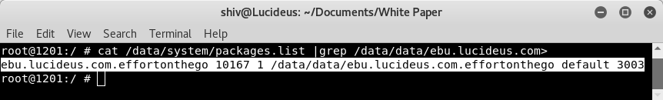

Exhibit 11

*Android application and its metadata*

### Notes for Developers

#### Excessive Permissions

An Android application should not request for the permissions that are not even required by the application. This increases the attack surface unnecessarily.

As the name implies, dangerous permissions request the data/resources that involve users private information, hence even if one dangerous permission is granted by the user, all the dangerous permissions in the same group are granted implicitly. So it is recommended that the dangerous permissions should be taken seriously and should only be requested if required.

#### Securing Application Components Using Permissions

Android applications are built of application components such as activities, receivers, services and providers. These application components interact with each other so as to perform intended functionalities.

In the scenarios where the scope of interaction of an application component is limited to that of same application it is recommended that the component developers should explicitly specify that the component is non-exported in AndroidManifest.xml by setting the attribute *android:exported* to false in the component's manifest element.

If the application component interacts with other components of the developer’s own application signed with same key. It is recommended that the developers must use signature level permission in [*android:protectionLevel*](https://developer.android.com/guide/topics/manifest/permission-element.html#plevel)and the same permission must be specified in the component's manifest element.

## 

## IPC: Inter Process Communication

IPC(Inter Process Communication) is a mechanism which allows processes to communicate with each other and allows them to synchronize their actions.

Linux operating system allows several mechanisms to achieve IPC via files, pipes, FIFO, sockets etc.

Android is built over Linux which supports the concept of [*Binder Framework*](https://www.nds.rub.de/media/attachments/files/2012/03/binder.pdf)[14] i.e. it allows IPC through [RPC](https://en.wikipedia.org/wiki/Remote_procedure_call)[15](Remote Procedure Calls) between client and server processes. Binder framework manages the underlying RPC mechanism and provides a simple user interface by exposing the APIs. The infrastructure provided by binders is used by in-process and cross-process calls.

### Intents

Intents supports the communication between application components. An intent is a simple message object that represents an intention. They are basically of two types:

#### Explicit Intents

Explicit intents specify the fully qualified class name of the component with which the application wants to communicate. Since the name of the component is explicitly mentioned in intent object the resolution happens by invoking the recipient.

#### Implicit Intents

Implicit intents are sent to the Android system for resolution. Implicit intents do not specify the application component to interact instead it includes other attributes that help the system to resolve the intent.

### Intent Filters

Intent filters help the Android system to resolve implicit intents as system compares the contents of the received implicit intent with the intent filters declared in the manifest file of other applications installed on the device.

* In the scenario where the contents of an intent matches the intent filter, the system invokes the component with matching intent filters and it also passes the intent object.
* In the scenario where multiple intent filters are compatible, the system displays a dialog box for a user to select among various application. The same is shown by Exhibit 12.

## 

## 

Exhibit 12

*Resolution of implicit intents*

### Notes for Developers

#### Insecure IPC Mechanisms

Developers sometimes use sockets(*localhost* network ports) for handling sensitive IPC. Having said that, binding on [INADDR_ANY](http://www.delorie.com/gnu/docs/glibc/libc_317.html)[16] is even worse than using [INADDR_LOOPBACK](http://www.delorie.com/gnu/docs/glibc/libc_317.html)[16] as it will allow application to communicate from anywhere. Similarly usage of world accessible for IPC is strongly discouraged.

It is recommended that developers should instead use Android IPC mechanisms which allows the verification of identity of the application that are trying to interact through IPC. For Ex: Usage of content provider is an efficient and secure way of sharing data with other applications than conventional world accessible files since it offers fine-grained and dynamic access control in terms of read and write permissions.

#### Insecure Android Broadcasts

Android allows applications to use broadcast to send messages to multiple applications through the following ways:

**Normal Broadcast** through [*Context.sendBroadcast()*](https://developer.android.com/reference/android/content/Context.html#sendBroadcast(android.content.Intent,%20java.lang.String))[17]: The normal broadcasts are asynchronous broadcasts i.e. these broadcasts are sent to every registered receiver and they act in an asynchronous fashion.

**Ordered Broadcast** through [*Context.sendOrderedBroadcast()*](https://developer.android.com/reference/android/content/Context.html#sendOrderedBroadcast(android.content.Intent,%20java.lang.String))*[18]:* The ordered broadcasts are delivered based on priority associated with every registered receiver. Priority is defined through “*android:priority*” attribute. Receivers with higher priority received it before those with lower priority.

**Sticky Broadcast** through [*Context.sendStickyBroadcast()*](https://developer.android.com/reference/android/content/Context.html#sendStickyBroadcast(android.content.Intent))[19](*deprecated in API 21*): These broadcasts are sticky in nature as they stay around even after completion of broadcast such that receivers can receive these intents even after their dormancy.

The following are the possible security issues associated with public broadcasts:

* Sensitive Data Exposure: In the scenario where an application sends sensitive data in a public broadcast, a malicious application installed on user’s device could register a receiver with intent filters having all possible actions, data and categories, in order to receive all public broadcasts*.*
* DOS(Denial of Service):In the scenario of ordered broadcast a malicious application installed on user’s device could register a malicious receiver with high priority in order to receive the broadcast on priority. On receipt of the broadcast the malicious receiver could either drop the broadcast or inject malicious data, resulting into the broadcast that is ultimately returned to the sender causing DOS.

It is recommended that developers should use explicit intents if the intent is destined for a single receiver and otherwise use[*Local Broadcast Manager*](https://developer.android.com/reference/android/support/v4/content/LocalBroadcastManager.html)[20] when the broadcast is not a public broadcast. Local broadcast manager is a helper class to register local broadcast receiver and to send local broadcasts. The broadcast remains within application and never goes outside the current process. This is an efficient and secure way of implementing local broadcasts.

In the scenarios where the broadcast is to be sent to the receiver of the other application signed with the same key it is recommended that signature permission must be created in the application manifest and the same must be used at the time of initiating broadcast.

If the application has to interact with the broadcast receiver of other applications the broadcast should never contain any sensitive data.

#### Insecure Implementation of Pending Intents

A pending intent is an intent whose execution can be delayed. A pending intent can be sent to any application and the receiving application can perform actions corresponding to it with same privileges and permissions as that of the original application. Using pending intents, we allow a foreign application to perform operations corresponding to intent as if the the operations are performed by the very own application.

Since pending intents allows foreign applications to perform actions corresponding to it, with the privileges of the original application and hence it must be developed with security in mind.

Using an implicit intent for the pending intent is highly discouraged as any application installed on user’s device could intercept the implicit intent and pass it on to an inappropriate location, while both the intent originator and the intent recipient would remain unaware that the intent had been intercepted. This could lead to sensitive data exposure or redirection of intent that could lead to unintended behavior.

## 

## 

## Exploit Mitigation Techniques

Buffer Overflow is an anomaly where a program/process while writing data to a buffer( fixed length [buffer](http://searchcio-midmarket.techtarget.com/definition/buffer) block of memory) overwrites adjacent memory locations of a buffer. It is a serious software anomaly, since if exploited it can even allow an attacker to control the underlying process. Exhibit 13 shows the simple example of buffer overflow.

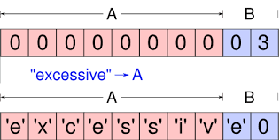

Exhibit 13

*Buffer Overflow*

*Source:* [*Wikimedia*](https://commons.wikimedia.org/wiki/File:Buffer_overflow_basicexample.svg)*[21]*

In the usual scenario of exploitation of buffer overflow vulnerability, attackers inject code into the adjacent memory locations of a buffer and then redirects the execution to the injected code. This allows an attacker to execute code with the privileges of a vulnerable program/process. Attackers can also inject the garbage input to crash the running process to create DOS(Denial of Service)

Android applications can have native components that are built using native code(C/C++). Native code can create lots of security issues as any input into Android native code can lead to memory exploitation issues and can cause code execution or may crash the application.

Android supports technologies like [*ASLR*](https://en.wikipedia.org/wiki/Address_space_layout_randomization)*[22][23]*(Address Space Layout Randomization), [*NX*](https://en.wikipedia.org/wiki/NX_bit)*[23][24]*(Never eXecute), [*ProPolice*](https://en.wikipedia.org/wiki/Buffer_overflow_protection#PROPOLICE)*[23[25]]*, [*safe_iop*](https://www.wiley.com/en-us/Android+Hacker%27s+Handbook-p-9781118608647)*[23]* etc. to mitigate risks associated with common memory management issues.

### ASLR

ASLR is a mitigation concept that prevents exploitation of memory corruption issues. As the name suggests ASLR randomly arranges the address space position of key modules of a process like base of executable, stack, heap etc in order to bring randomness.

### Data Execution Prevention

Android supports the concept of data execution prevention which prevents attacker from executing the arbitrary code by disallowing the execution of data.

Android supports this concept from API level 9 and above by supporting the concept of hardware-based *NX*(No eXecute) to prevent code execution on the stack and heap.

### Protecting Stack

Android also supports techniques to combat stack-based buffer overflows. The concept of [*stack canaries*](https://en.wikipedia.org/wiki/Buffer_overflow_protection#Canaries)*[26]* also known as cookies is used. It is a random value that is stored before the return address of current stack frame and when a overflow occurs the canary is also modified which indicates that the occurrence of buffer overflow.

Android supports the concept of ProPolice from API level 3, the former is a more effective than Stackgaurd.

### Notes for Developers

#### Leveraging Underlying Exploit Mitigation Techniques

Android supports exploit mitigation techniques such as ASLR, NX, PRoPolice etc. but the underlying Linux kernel enables these protections only and only if the binaries are compiled using these security options. It is strongly recommended that developers must use these security options.

* ASLR: Linux kernel enables and disables ASLR based on information in the information in the binary format of executable code module.

Position independent binaries can be created when the executable is compiled with *-pie* and *-fpie* flags.

* Non Executable Stack: Architectures corresponding to Android 2.3 and later supports non-executable pages by default including non executable stack and heap. But the underlying linux kernel marks the underlying stack memory as executable unless the same is explicitly specified through the compilation options of binary.

The binary must be compiled with *-znoexecstack* option as it adds non executable flag for *GNU_STACK* program header.

* Stack Protection: In order to combat stack based buffer overflows the ProPolice exploit mitigation must be enabled. The ProPolice stack protection is enabled by using -fstack-protector compilation option.

All the exploit mitigation mechanism supported by Android platform must be enabled while compiling the binaries. Google has made this very simple for Android developers as developers can use Android NDK(Native Development Kit) as it enables all the exploit mitigation techniques by default. It is strongly recommended that the developers use the latest version of the Android NDK and must also target highest possible Android API versions.

#### Usage of Banned Functions and Vulnerable Libraries

Even though Android provides lots of exploit mitigation techniques and Android NDK enables them by default, this should not be considered as an excuse for insecure coding. Developers must not completely rely on the security of the underlying platform and instead concentrate more towards coding a secure and robust application.

The usage of [banned functions](https://msdn.microsoft.com/en-us/library/bb288454.aspx)[27] like *gets()*, *puts()*, *strcpy()*, *strcat()* etc. is very strongly discouraged. Avoiding these banned functions in native code can lead to significant reduction of potential security issues in native code.

Developers should also not use vulnerable third-party libraries. It is recommended that the updated libraries with all the latest security fixes must be used if required.

When dealing with native code, developers must consider each entry point to be a potential security threat and should scrutinize each entry point. For example, any data read from a world writable file, received over a network or through IPC should be validated properly before processing it through native code.

It is also recommended that the developers must follow [secure coding guidelines](https://wiki.sei.cmu.edu/confluence/display/seccode/SEI+CERT+Coding+Standards)[28][29][30] while developing the code. It is also recommended that [static code analyzers](https://www.owasp.org/index.php/Source_Code_Analysis_Tools)[31][32] should be used.

## 

## Application Signing

Android supports the concept of application signing such that it only allows signed application packages to be installed on Android device. Application signing ensures that the future updates to the application are authentic and come from the same author.

### Digital Signature

Before diving deep into the concept of digital signatures let us first understand the following concepts:

**Cryptography**

Cryptography is the science of hiding things. It is used for converting plaintext to cipher-text such that the confidentiality of the secret message is maintained. Basically cryptography is broadly classified into two categories:

* **Symmetric Key Cryptography:** It refers to the encryption methodologies where both the parties share the same key. The key is known as symmetric/secret key.
* **Asymmetric Key Cryptography:** It refers to the encryption methodologies where both the parties have different keys namely public and private key. It is also known as public key cryptography.

**Hashing**

Hashing is a cryptographic operation that converts the input message of any length to value of fixed length known as hash/message digest. It is implemented using a one way function i.e. it is not reversible. Cryptographic hash functions are used to determine the integrity of the input message.

## 

## 

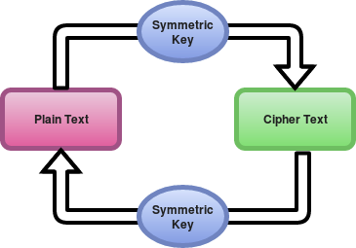

Exhibit 14

*Symmetric Key Cryptography*

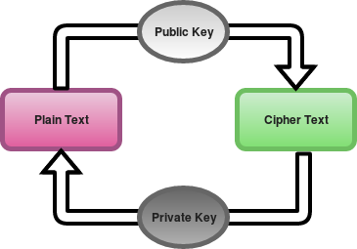

Exhibit 15

*Asymmetric Key Cryptography*

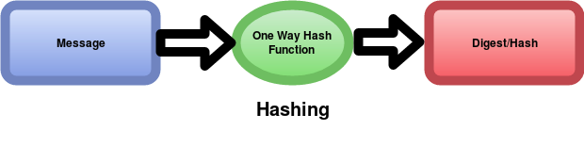

Exhibit 16

*Cryptographic Hash Function*

Now after understanding the basic cryptography mechanism it will be easier to understand the concept of digital signature.

Digital signature is an application of cryptography that uses the concepts of public key cryptography and cryptographic hash functions for demonstrating the authenticity of digital messages or documents.

A valid digital signatures provides an authenticity of the sender and along with that it helps the receiving party know that the integrity of the message is maintained.

Exhibit 17 very well explains the mechanism of generation and verification of digital signatures.

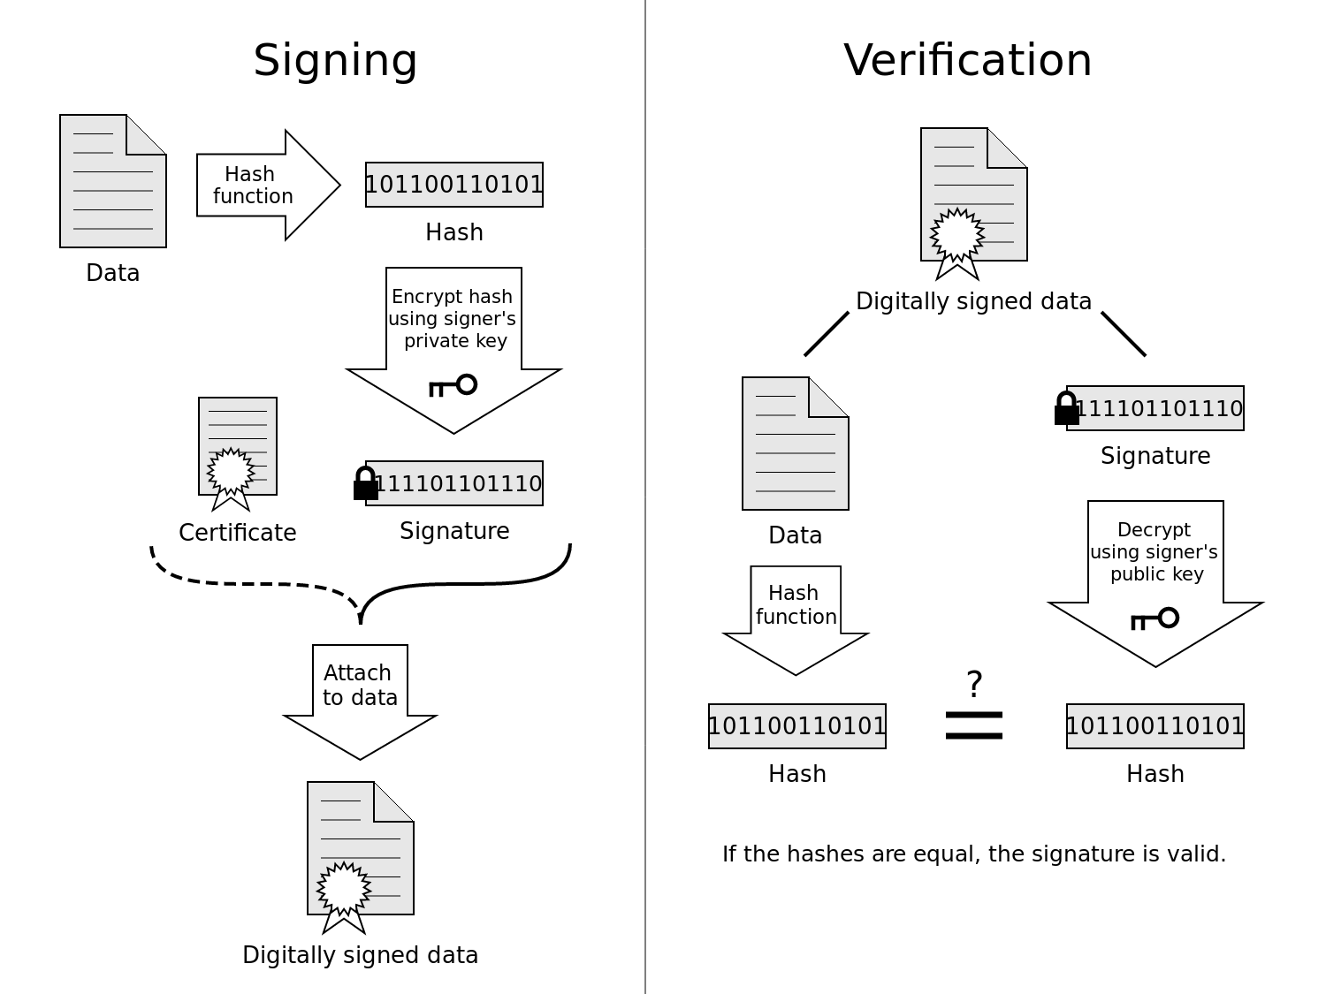

Exhibit 17

*Generation and Verification of Digital Signatures*

*Source:* [*Wikipedia*](https://en.wikipedia.org/wiki/Talk:Digital_signature#/media/File:Digital_Signature_diagram.svg)[33]

## Application Signing Process

For signing an Android application we need *Keystore.* A keystore is a store that contains one or more keys. Basically there are two types of keystores:

* Debug Keystore: It is used during debugging phase of the Android application development. The application signed using debug keystore can not be pushed to application stores such as Google Play.
* Release Keystore: It is used for the signing of the release build. The application signed with release keystore can be uploaded on application stores such as Google Play.

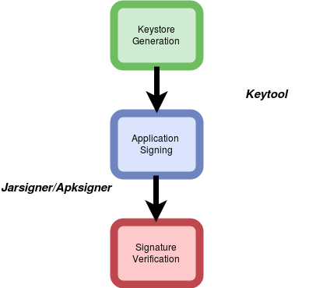

Exhibit 18

*Application Signing and Verification Process*

The following utilities are used during application signing:

[**Keytool**](https://docs.oracle.com/javase/6/docs/technotes/tools/windows/keytool.html)[34]**:** It is a Java utility and is part of Android SDK. It helps to manage cryptographic keys, X.509 certificate chains, and trusted certificates. As discussed, a keystore file may contain multiple keystores and each one of them is identified by a unique alias.

A Keystore file is protected by two passwords one for keystore itself and another for each entry in keystore.

It is recommended that the passwords used should be unique.

[**Jarsigner**](https://docs.oracle.com/javase/7/docs/technotes/tools/windows/jarsigner.html)[35]**:** It is also a Java utility that is part of Android SDK. The utility has two main purpose, one is signing java archive and the other is verification of signing. It generates digital signatures using key and certificate information from keystore.

Once the APK is signed two additional files are created in the application package namely MANIFEST.SF and CERT.XXX(where XXX depends on usage of underlying algorithm eg. RSA, DSA etc.)

[**Apksigner**](https://developer.android.com/studio/command-line/apksigner.html)[36]**:** It is signing utility that is developed by Google. Google introduced a new signing scheme(v2 Signing Scheme). It is used for the signing using scheme v2. This signing scheme is considered more efficient and it also provides more protections against unauthorized alterations to APK file.

### Notes for Developers

#### Insecure Signing Scheme

Signature scheme v1 only takes into the zip entries and ignores any extra bytes while calculating and verifying the signatures. A serious vulnerability ([*Janus Vulnerability-CVE 2017-13156*](https://www.guardsquare.com/en/blog/new-android-vulnerability-allows-attackers-modify-apps-without-affecting-their-signatures)*[37]*) was also identified in signature scheme v1 that allows attacker to modify the code in application without affecting its signature. Applications signed with signature scheme v2 and running on supporting device are protected against the vulnerability.

It is recommended that developers must use signing scheme v2 over signing scheme v1 as the latter do not properly protect the APK from unauthorized alterations. Signature scheme v2 treats the APK as a *blob* and performs the signature checking across the entire file.

#### Insecure Signing Algorithms

During application signing usage of weak cryptographic algorithm such as *SHA-1*, *RSA-1024* etc. should be avoided in order to prevent security issues. Hashing algorithms such as MD5, SHA-1 etc. are vulnerable to [collision](https://en.wikipedia.org/wiki/Collision_attack)[38][39][40] attacks whereas encryption algorithm such as RSA-1024 is vulnerable to multiple known cryptographic attacks making it weak and officially deprecated.

It is also recommended that strong hashing algorithm such as *SHA-256* be used. Also, instead of *RSA-1024*, *RSA-4096* or *RSA-2048* should be used. However, *SHA256withRSA* and other better hashes are only supported on API level 18 and above. It is without a doubt a security versus compatibility trade off on which developers need to take a decision.

## 

## Android Keystores

### Keystore

As the name implies keystore is a storage facility that is used to store keys and certificates. It can be implemented by a file or a hardware device. Generally it is used to store the following entries:

* **Private Key:** The encryption key that is used during asymmetric encryption. It is used to sign a digital signature.
* **Certificate:** It is a signing certificate that contains the public key(asymmetric encryption) and metadata.
* **Symmetric Key:** It is secret key that is used for symmetric key cryptography.

There are different types of keystore depending on the underlying implementations. For example, [JKS](https://docs.oracle.com/javase/7/docs/api/java/security/KeyStore.html)[41](Java KeyStore), [BKS](https://bouncycastle.org/specifications.html)[42](Bouncycastle KeyStore) etc.

### Android Keystore

Android platform supports the concept of Android Keystore. Android Keystore system allows the secure storage of cryptographic keys that makes the extraction of the stored keys difficult. The concept of Android Keystore has undergone a tremendous evolution as shown in Exhibit 18 and further discussions below.

Android supported the concept of [*System Credential Store*](https://www.amazon.in/Android-Security-Internals-Depth-Architecture/dp/1593275811#reader_1593275811)*[43]* from Android 1.6. It was used to store the encryption key that was derived using user’s password. The key was used to encrypt VPN and WiFi EAP credentials such that these credentials were stored encrypted on disk. The System Credential Store was only accessible to system applications and no public APIs were available.

Android introduced [KeyChain API](https://developer.android.com/reference/android/security/KeyChain.html)[44] in Android 4.0-API 14. This API was provided to regulate the access to System Credential Store. It allowed application developers to import keys to system store. These keys were owned by *System* user. The keys stored using Keychain API were not *per-app* keys, but any application could request access to keys.

Android introduced the concept of Android Keystore Service in Android API 4.3-API 18. It supported the concept of *per-app* keys such that key generated for a given application could not be accessed by other application. The service runs as *Keystore* user and the concerned files are stored in */data/misc/keystore*.

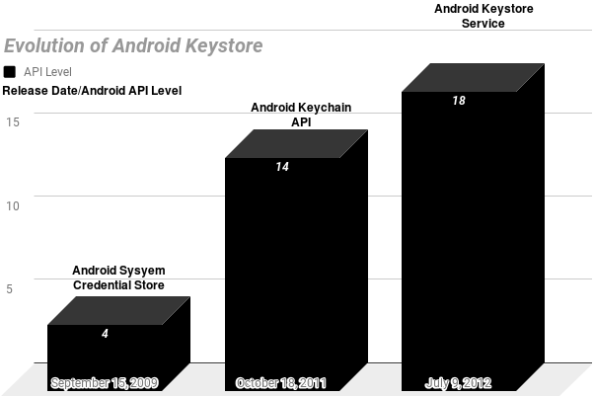

Exhibit 19

*Evolution of Android Keystore*

#### Hardware Backed Keystore

##### TEE:Trusted Execution Environment

As the name implies [TEE](https://en.wikipedia.org/wiki/Trusted_execution_environment)[45](Trusted Execution Environment) is a secure region of the main processor. TEE is meant for handling sensitive data such that it ensures that sensitive data is stored, processed and protected in an isolated, *trusted environment*.

[ARM](https://en.wikipedia.org/wiki/ARM_architecture)[46](Advanced [RISC](https://en.wikipedia.org/wiki/Reduced_instruction_set_computer)[47](Reduced Instruction Set Computing) Machine) is a family of RISC architecture for computer processors. Organizations such as Qualcomm and Texas Instruments make CPUs based on the architecture licensed from ARM. ARM implements the concept of TEE through [*ARM Trustzone*](https://www.arm.com/products/security-on-arm/trustzone)*[48]*. This technology provides hardware features to create a secure environment separated from normal execution environment.

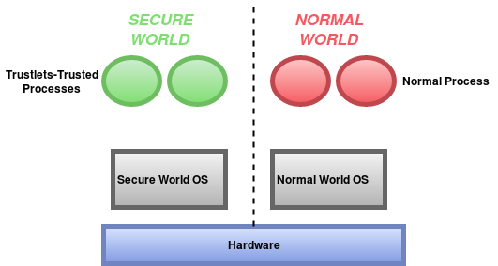

Exhibit 20

*ARM Trustzone*

*Source:* [*Analysis of Secure Key Storage Solutions on Android*](http://www.cs.kun.nl/~erikpoll/publications/AndroidSecureStorage.pdf)

Exhibit 20 shows separation of the hardware in two worlds namely secure world and normal world. Two isolated virtual environments are created that includes virtual processors and virtual resources such that the processes running in normal world can not access the secure resources directly.

#### Keystore Entries

Keystore service maintains different directories for different user of Android device. The entries are stored in */data/misc/keystore/user_x* where x is the Android user ID, starting with 0 for the primary user. Exhibit 21 shows the storage of entries in *user_0* directory. As shown, each entry is owned by *keystore* user and is only accessible to the same. The entries have a common naming convention of ***XXX_YYY_ZZZ****.* Where each underscore separated value has the following meaning:

* *XXX* isUID of the application that created the keystore.
* *YYY* is type of entry, it can be one of the following:
  + CACERT-CA Certificate
  + USRCERT-User Certificate
  + USRPKEY-Private Key
* *ZZZ* is alias name.

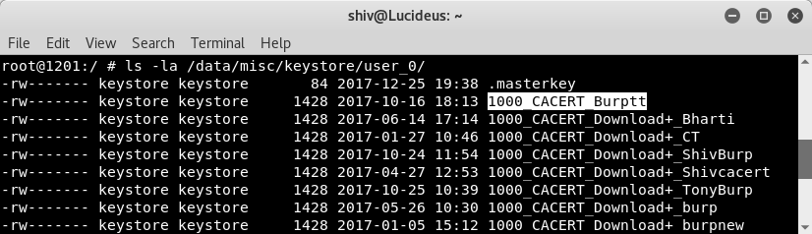

Exhibit 21

*Keystore Entries*

Whenever any Android application generates a key pair using [*KeyPairGenerator*](https://developer.android.com/reference/java/security/KeyPairGenerator.html)*[47]* API. The following entries are created in the keystore:

* USRPKEY: The file stores the key pair parameters including the private key.
* USRCERT: The file stores the certificate for the publickey.

As shown in Exhibit 21, the very first entry in the keystore directory is *.masterkey,* when the device is protected using secure lock screen credential (e.g., password, PIN, or pattern) a random 128-bit AES master key is used for encryption. This key is encrypted through a key derived from user’s credential using [*PBKDF*](https://en.wikipedia.org/wiki/PBKDF2)*[48]*(8192 rounds of *PKCS5_PBKDF2_HMAC_SHA1*) and the encrypted key is stored in *.masterkey* file.

For hardware-backed keystore, the key files are encrypted using a device-specific key that is stored in TEE and cannot be retrieved to normal world applications even with root access. When the key pair is generated with [*setEncryptionRequired*](https://developer.android.com/reference/android/security/KeyPairGeneratorSpec.Builder.html#setEncryptionRequired())*[49]* set to true, then keys will be *further* encrypted with a key derived from secure lock screen credential (e.g., password, PIN, or pattern). Having said that, the following are the cons if this security layer is used:

* The successful key pair generation requires that the secure lock screen (e.g., password, PIN, pattern) is set up.
* The generated key pair are automatically deleted when the secure lock screen is disabled or reset.
* The generated key pair cannot be used until the user unlocks the secure lock screen after boot.

For API level 22 and below, the functionality/bug in Android keystore encrypts all the keystore entries using masterkey, which may cause the deletion of keystore files whenever lock screen credential is changed. In API level 23, keys which do not require encryption at rest i.e. where *setEncryptionRequired* is false, will no longer be deleted when secure lock screen is disabled or reset. However, keys which require encryption at rest will be deleted during these events.

## SafteyNet: Developers Friend

SafteyNet is a set of services and APIs that was introduced by Google in 2013. It helps users and developers to secure the Android platform. It protects the application against security threats, including device tampering, bad URLs, [PHAs](https://source.android.com/security/reports/Google_Android_Security_PHA_classifications.pdf)[49](Potentially Harmful Applications), and fake users.

[Google Play Services](https://en.wikipedia.org/wiki/Google_Play_Services)[50] starts an always-running service named [*snet*](https://koz.io/inside-safetynet/)*[51]*. This service frequently collects various pieces of data from the device and sends it back to Google’s cloud, this makes Android devices to contribute security-related information to Google’s cloud services. The information includes security events, logs, configuration etc. The collected information is used in multiple ways such as ecosystem analysis and threat profiling of the device.

Before 2016, user’s enabling installation from unknown sources were prompted to enable SafteyNet but from 2016 SafteyNet is enabled by default on all Android devices with Google play.

### SafteyNet APIs

Google provides the following APIs that helps developers to assess the health of Android device in which the application runs. It also help developers to secure the Android application. The usage of SafteyNet API is optional. However, it is strongly recommended that developers must leverage the same.

* [SafetyNet Attestation API](https://developer.android.com/training/safetynet/attestation.html)12]
* [SafetyNet Verify Apps API](https://developer.android.com/training/safetynet/verify-apps.html)[52]
* [SafetyNet reCAPTCHA API](https://developer.android.com/training/safetynet/recaptcha.html)[53]
* [SafetyNet Safe Browsing API](https://developer.android.com/training/safetynet/safebrowsing.html)[54]

#### SafetyNet Attestation API

SafteyNet Attestation API helps the developers to check the security and compatibility of the Android device in which the application runs. The API examines the software and hardware information on the device so as to provide confidence to developers about the integrity of a device and the application itself.

The features provided by this API is broadly categorized below:

##### Compatibility Test Suite Results

[CTS](https://source.android.com/compatibility/cts/)[55](Compatibility Test Suite) is a free and commercial-grade test suite for Android and it represents the "mechanism" of compatibility. For the certification process for Google’s applications, device manufacturers have to submit their CTS test results. SafteyNet creates the profile of the device based on the hardware and software information of the device. The service then attempts to find this same profile within a list of device models that have passed Android compatibility testing. If the device in which the application is running meets the security and compatibility requirements of Google the *ctsProfileMatch* response is returned.

##### Basic Integrity Checks

The API also helps us to check the integrity of the device so as to determine whether or not the particular device has been tampered with or otherwise modified. This provides developers with confidence about the integrity of a device in which the application is running.

##### Application Integrity Checks

SafteyNet Attestation API allows developers to check the integrity of the application that is using the API so that developers can assess whether the calling app is legitimate.

##### Architecture

The workflow involved in SafteyNet Attestation API is explained below.

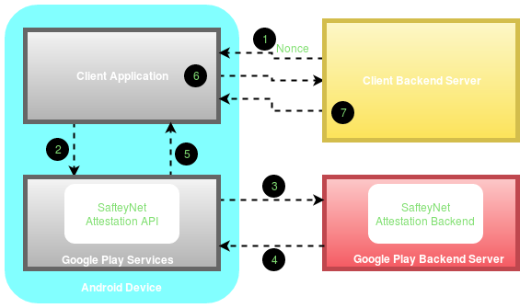

Exhibit 20

*SafetyNet Attestation API protocol*

1. A [nonce](https://en.wikipedia.org/wiki/Cryptographic_nonce)[56] is a random token generated in a cryptographically secure manner. It is recommended that the nonce must be generated at server side and sent to client over a secure connection. Usage of nonce prevents from replay attacks.
2. The application makes a call to the SafetyNet Attestation API via Google Play Services.
3. The SafetyNet Attestation API communicates with the backend server and requests a signed response.
4. The SafteyNet Attestation backend sends the response to Google Play services. The received response is formatted as a [JWS](https://tools.ietf.org/html/rfc7515)[57](JSON Web Signature). The following JWS excerpt shows the format of the payload data:

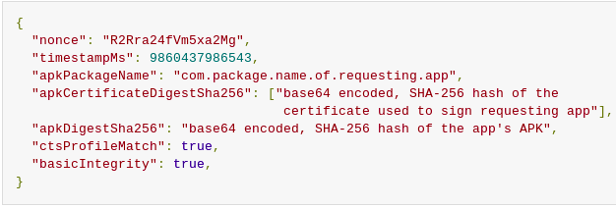

Exhibit 22

*Attestation Response*

Source: [*Google SafteyNet Attestation Document*](https://developer.android.com/training/safetynet/attestation.html)[12]

* *ctsProfileMatch*: The value contains the result of CTS compatibility. If the value is true then the profile of the device running the application matches the profile of the device that has passed Android compatibility testing.
* *basicIntegrity*: The value contains the results of device’s integrity checks. If the value is true then the device running the application wasn't tampered with. If the result is true, it doesn't mean the device has passed Android compatibility test.
* *apkPackageName*: The parameter provides the package name of the application invoking SafteyNet Attestation API.
* *apkCertificateDigestSha256*: The parameter provides the base64 encoded SHA-256 digest of certificate used to sign the application.
* *apkDigestSha256*: The parameter provides the base64 encoded SHA-256 hash of the application’s APK file.

1. The JWS attestation response is then sent to the application requesting the services.
2. One of the best thing of SafteyNet Attestation API is that, it can be verified at the application server side. Application client will send the received response to server for the verification.
3. Application server processes the attestation response and sends the result of the verification process back to the application. The application server can then directly ask Google to verify the JWS signature (or do it itself) and proceed to act on the results on the server side, for example deny API access to the client.

Note: If the device running the application is CTS compatible, this does not mean that the device is vulnerability-free. Google does not check if a device is up to date or vulnerable to public exploits, as part of the SafetyNet service. It checks if it has been tampered compared to an expected normal and safe state.

SureShot Solution

As already discussed, there is no sure-shot mechanism of identifying the rooted device. Root cloakers run with root privileges hence root detection can be bypassed but, the checks indeed increases the attack complexity thus reduces the overall risk. However, it is strongly recommended that SafteyNet attestation API should be implemented in the suggested way.

Application Integrity

The APK information *apkPackageName*, *apkCertificateDigestSha256* and *apkDigestSha256* for the integrity checks of the application should only be trusted if *ctsProfileMatch* is true.

Secure Implementation

* It is strongly advised that security decisions must happen on the server and not at the client as the client side code can be very easily tampered. Instead, developers should send the entire JWS response to their own server over a secure connection, for the verification. The signed JWS response must be validated before processing.
* It is recommended that the attestation check must be performed for all the critical workflows such as login, financial transactions etc. However, attestation introduces latency, bandwidth, power usage etc. and hence a balance between security and usability must be maintained.

#### SafetyNet Verify Apps API

In early 2012, Google introduces an automated security scanner, to scan new and existing applications for for malware, spyware, and trojan viruses. In 2017, Google launched [Google Play Protect](https://en.droidwiki.org/wiki/Google_Play_Protect)[58] which is a suite of safety services such as Verify Apps.

As per [Google’s Android Security 2016 Year In Review](https://source.android.com/security/reports/Google_Android_Security_2016_Report_Final.pdf)[59], Google scans all the Android devices at least once every six days and devices with risk factors are scanned more frequently. Google Play Protect improves the security of the underlying device in the following ways:

* It scans the applications before downloading from Google Play Store and blocks the installation if the application is found to be a PHA(Potentially Harmful Application).
* It regularly scans the installed applications on the device and if it finds the PHA, it may prompt the user to delete the application or automatically remove the same.

Google Play Protect is available on all Android devices with Google Play installed. It helps users to secure their Android device. Moreover, it also helps application developers to get security insights of the devices on which the application is running using SafetyNet Verify Apps API.

SafteyNet verify Apps API allows the application to interact with Verify Apps feature on device so as to protect the device against PHAs. It is unlike SafteyNet Attestation API which checks for the device integrity.

Installed malicious applications on user’s device may interact with the other applications to let them behave in unintended manner. It is strongly recommended that for the applications involving flow of sensitive data, application developers should confirm that the device on which the application is running is protected against malicious applications.

#### SafetyNet reCAPTCHA API

SafteyNet reCAPTCHA API protects the application from malicious traffic. It is developed to authenticate that the user is human and not a bot or an automated tool. It uses an advanced risk analysis engine to protect the applications from malicious traffic generated using a bot, automated tool etc. If the service suspects that the user interacting with the application may be a bot rather than a human, it serves a CAPTCHA that a human must solve before the application can continue the execution.

#### SafetyNet Safe Browsing API

Google introduced safe browsing in 2005. It allows the applications to check URLs against unsafe web resources such as phishing websites, deceptive sites, malware hosting websites and hence prevents a user from security threats. Whenever a user tries to access such web resources, safe browsing enabled web browsers displays a warning to inform users regarding the malicious web resource. The warning displayed is shown by Exhibit 22.

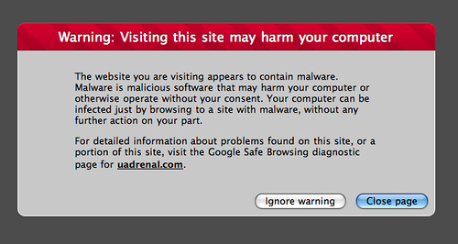

Exhibit 23

*Safe Browsing Warning Message*

Safe Browsing is a very popular security feature introduced by Google. Approximately a billion users take advantage of Safe Browsing everyday. (Source: *Google’s Android Security 2016 Year In Review*[59]). The protection is already enabled on the chrome browser on Android devices.

In mid-2016, Google released Safe Browsing API for third-party developers, to protect their applications from malicious web resources. The application can use SafteyNet Safe Browsing API to determine whether a particular URL has been classified by Google as a known threat. Developers can use Safe Browsing’s database of known harmful URLs to secure the application. It is strongly emphasised that application developers should use this API to take full advantage of Google's Safe Browsing service on Android in the most resource-optimized way.

### Notes for Developers

#### Lack of Rate Limiters

The lack of implementation of rate limiters on critical workflows such as authentication, registration, initiating Email or OTPs etc. allows an attacker to exploit the service using an automated tool. Few of the such instances are briefly explained below:

* Authentication Requests: An attacker may bruteforce user’s password/PIN/OTP in order to bypass authentication and login into victim’s account.
* Initiating Email/OTP: An attacker may initiate several Email and/or OTP requests for spamming, Denial of Service(DOS) etc.

It is advised that the developers must implement rate limiters such as CAPTCHA in order to block malicious traffic generated by automated tool/bots. The SafetyNet reCAPTCHA API can also be used for it to protect the application from such attacks.

#### Insecure Implementation of Attestation API

SafteyNet Attestation API is the robust API that can be used by application developers to build a secure Android applications. Unfortunately sometimes the API is not implemented in the proper way by the application developers. The following should be considered while implementing the Attestation API:

* Nonce Implementation: The nonce should be generated using a cryptographic secure random function at the server side. It is recommended that the nonce should be derived from multiple user-specific details and a timestamp(Ex. Hash of username and timestamp) to prevent replay attacks. Once the nonce is generated at the server side it should be shared over secure connection with the client and during the verification of attestation response it should also be validated in the JWS response.
* Client Side Verification: Verification of the attestation response at the client side is strongly discouraged as the verification logic can be easily tampered by modifying and repacking the application.
* Secure Server Side Verification: The verification must happen at the server side such that the attestation response must be sent to the server over a secure communication channel and the origin and the integrity of the JWS message must be validated before processing it further.
* Updated Version: The SafetyNet Attestation API is continuously evolving and the security features are also improving with time. It is recommended that the developers should use the latest version of SafteyNet APIs.

# 

# Some Other Security Practices

## Secure Crypto Implementation

Cryptography is a science of hiding things. There are several scenarios where the usage of cryptography is required to protect the confidentiality and integrity of sensitive user data. The strength of cryptography lies in its configuration and implementation. For an instance, while implementing cryptography, using a strong cryptographic algorithm alone is not enough as the security of otherwise strong algorithms can be affected through their implementation. For Example, poor key management may easily compromise strong encryption algorithms.

### Reducing Unnecessary Attack Surface

In the scenario where cryptography is required to secure the local data storage, developers must avoid the storage of unnecessary data in the application’s local data storage. During the security evaluations of different Android applications, often it is observed that the code snippets introduced during development/debugging phase of the application to store the sensitive information and/or [Personally Identifiable Information(PII)](https://en.wikipedia.org/wiki/Personally_identifiable_information)[61] of the user in the application’s local data store were not removed by the a application developers before releasing the production build. It is recommended that the application should not capture unnecessary sensitive data. Only the required sensitive data should be captured and must be securely handled.

In scenario, where the application is required to store sensitive data or user’s PII in the local data storage of the application, developers must manage the data securely using secure crypto implementations.

### Avoid Usage of Insecure and Custom Cryptographic Algorithms

The cryptographic algorithms and protocols that were considered as secure couple of years back aren't viewed as secure any longer this is in indeed due to the advancement in the computation. Established algorithms which once required significant computing time, can now be broken down in a matter of days or hours. This means that with the expansion in computational power the security requirements must increase accordingly. Cryptographic algorithms must be up to date and in-accordance with the industry standards.

Usage of weak encryption algorithms such as DES, Triple DES, AES-ECB and hashing algorithms such as MD4, MD5, SHA-1 is not advised since these algorithms are vulnerable to known cryptographic attacks.

Usage of custom encryption algorithms are strongly discouraged. The standard algorithms undergo research and are well tested. Usage of custom algorithms is tedious, troublesome, and

likely to fail.

### It is recommended that following cryptographic algorithms should be used:

* **Confidentiality Algorithms:** AES-GCM-256 or ChaCha20-Poly1305
* **Integrity Algorithms:** SHA-256, SHA-384, SHA-512, Blake2
* **Digital Signature Algorithms:** RSA (3072 bits and higher), ECDSA with NIST P-384
* **Key Establishment Algorithms:** RSA (3072 bits and higher), DH (3072 bits or higher), ECDH with NIST P-384

Source: [*OWASP Mobile Testing Security Guide*](https://github.com/OWASP/owasp-mstg/blob/master/Document/0x04g-Testing-Cryptography.md)[60]

### Avoid Insecure Key Derivation Mechanisms

As already discussed, the strength of cryptography not only depends on the cryptographic algorithms but also on its implementation. Key management is one of the most important process since poor key management may easily compromise secure and strong algorithms. The confidentiality and integrity provided by cryptographic processes such as symmetric encryption and keyed hashes (MACs) depends on the secrecy of the encryption key involved. In the event that the key is revealed, the confidentiality and integrity provided is lost.

During security analysis of various Android applications often it is found that the developers hard-code encryption keys in the application source code. Sometimes, it is also observed that the encryption keys are stored in the application resources or local data store. This way of key management is insecure as an attacker can get access to the encryption keys by reverse engineering the application. Even if the source code is obfuscated, developers must not hardcode the encryption keys since obfuscation only increases the analysis time and can be easily bypassed using dynamic instrumentation.

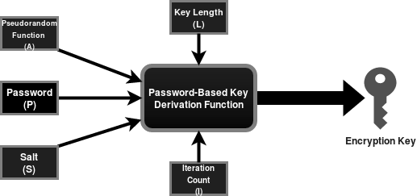

Exhibit 24

*Working of PBKDF2*

Since the security of information protected by cryptography directly depends on the robustness of the keys, so the encryption keys must be securely managed. It is recommended that developers use PBKDF2(Password Based Key Derivation Function) for deriving the encryption key as shown by Exhibit 24. It applies a cryptographic pseudo random function(A) such as HMAC to the input value(P) along with a salt(S) and repeats the process for specified iterations(I) to produce a key of the specified length(L). The algorithm inherently blocks brute force attacks.

While implementing PBKDF2, developers must take care of the following:

* The input value to the algorithm must not be hardcoded in the application’s source code and instead a user supplied password should be used to derive encryption key. It is also recommended that the application must enforce the usage of strong password policies to further prevent possibilities of brute-force attacks.
* The strength of PBKDF2 lies in its iteration count as it traditionally serves the purpose of increasing the cost of key generation from an input value. If the iteration count is too low, the feasibility of an attack increases as an attacker may compute "rainbow tables" for the application and may easily determine the hashed password values. It is recommended that the key derivation function should be used with 10,000 or more rounds of iteration so as to make brute-force attacks expensive.
* The encryption key can be derived at the time of registration/first login and can be used to encrypt sensitive data and the same key can be used to decrypt sensitive data whenever correct password is supplied.

### Secure Pseudo Random Number Generation

During the function flow of the application, developers often use random numbers for nonce, salt, IV(Initialization Vector) etc. It is strongly recommended that the application developers use secure random numbers instead of conventional random numbers. Since the latter does not withstand cryptographic attacks. Application developers must use *java.security.SecureRandom* instead of *java.util.Random* so as to prevent insecure randomness errors that may occur in a security-sensitive context.

Also, when random numbers are used application developers must avoid explicit seeding to prevent deterministic random number generations. For API levels 17 and below, calling *setSeed* method will make the RNG (Random Number Generator) into a Deterministic RNG as it will only use the supplied seed that may lack entropy. The default implementation automatically seeds itself using the system random number generator whereas for API level 18 and above the specified seed is just added to the random state, so the RNG stays fully random.

## 

## Securing Android Webviews

Android allows developers to display web content directly into their application through Webviews. In the past, Webview was tightly coupled with the Android platform however, from Android 5.0

Google seperated Webview from the core Android platform in order to aid separate security updates. It is shown by Exhibit 25.

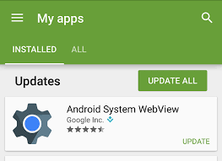

Exhibit 25

*Decoupling of Webview from Android OS*

Usage of Webviews is very developer friendly and the same is strengthened over the years but in spite of that it can be easily abused. The following sections describes the recommendations of securely using webviews.

### Webview Hardening

It strongly recommended that the Webview must be hardened properly before usage. The following key points should be taken care while working with Android webviews.

* **Usage of JavaScript:** Whenever a webview instance is instantiated the JavaScript is disabled by default. It is recommended that the JavaScript should not be enabled unless it is very much required as the usage of the same increases the attack surface. If JavaScript is disabled, the impact of Man In The Middle attack is reduced and it also prevents the application from Cross Site Scripting(XSS) attacks.

If the usage of JavaScript is required, then all the input consumed by the application must be validated at the server side. It is also recommended that the input must be encoded using encoding schemes such as URI/HTML encoding before it is sent as the part of HTTP response.

* **Access to Content Providers:** Whenever an instance of Webview is created, by default it has access to the content providers which may unnecessarily increase the attack surface. In scenario where the access to content providers is not required and the same is not explicitly disabled, a compromise of Webview will also lead to the compromise of content providers.

It is recommended that if the access to content providers is not required it should be explicitly disabled using the *setAllowContentAccess* method.

* **Access to File System:** Whenever an instance of Webview is created, by default it has access to the file system which may unnecessarily increase the attack surface. In scenario where the access to file system is not required and the same is not explicitly disabled, a compromise of Webview will also lead to the compromise of file system.

It is recommended that the if the file system access is not required it must be explicitly disabled using the *setAllowFileAccess* method.

* **File Access From File URLs:** For API level 15 and below, whenever an instance of webview is created, by default it allows JavaScript running in context of a file scheme URLs to access resources on the filesystem. It is recommended that If the application supports API level 15 and below, it must be explicitly disabled using *setAllowFileAccessFromFileURLs*to reduce the attack surface.
* **Universal File Access From File URLs:** For API level 15 and below, whenever an instance of webview is created, by default it allows JavaScript running in context of a file scheme URLs to access content from any origin and the content from other file scheme URLs. It is recommended that If the application supports API level 15 and below, it must be explicitly disabled using *setAllowUniversalAccessFromFileURLs* and *setAllowFileAccessFromFileURLs* respectively so as to reduce the attack surface.

### Preventing Excess Authorization

Android enables developers to inject Java objects into the webview, it allows JavaScript to access the Java object methods. Developers can create a bridge between JavaScript and Java using *addJavascriptInterface* method. This is a very powerful feature, but it had serious security issues for API levels JELLY_BEAN and below.

API level 16 and below, allows JavaScript to execute all the public methods (including the inherited ones) which can be abused in the scenario where *addJavascriptInterface* method is invoked with untrusted content in a WebView, leaving the application vulnerable to scripting attacks using reflection to access public methods through JavaScript.

Application developers should refrain from calling *addJavascriptInterface,* if the usage is required developers must not support vulnerable Android versions (API level <=16).

Also, the following things must be taken care when registering the JavaScript interface:

1. The JavaScript content should be shared over a secure connection.
2. The JavaScript content should not be loaded from a third-partyserver.
3. Security measures to prevent Cross Site Scripting(XSS) attacks must be strictly followed. In order to secure the application from XSS attacks, application developers can refer [XSS Prevention Cheat Sheet](https://www.owasp.org/index.php/XSS_(Cross_Site_Scripting)_Prevention_Cheat_Sheet)[62].

For API Levels 17 and above this issue was fixed as only public methods annotated with JavascriptInterface could be accessed through JavaScript.

## OWASP Dependency Check

Application developers often use components(e.g., framework libraries) that aren’t written by them, as it is usually not realistic to write the entire application code from the scratch. It is very usual that these application components have vulnerabilities. An attacker can identify these vulnerable components during information gathering phase and can then frame the attack using publicly available exploit code.

There are known vulnerabilities in common libraries for Android development such as [*OkHttp*](https://www.cvedetails.com/cve/CVE-2016-2402/)*[63]* and [*Apache Commons I/O*](https://www.cvedetails.com/product/32731/Apache-Commons-Collections.html?vendor_id=45)*[64]*.

In order to reduce the attack surface, application developers must remove unnecessary dependencies, features, components, files etc. Also, application developers must maintain an inventory of the versions of both client side and server side components and sources like [*CVE*](https://cve.mitre.org/)[65] and [*NVD*](https://nvd.nist.gov/)[66] must be continuously monitored for vulnerabilities.

Fortunately [*OWASP Dependency Check*](https://www.owasp.org/index.php/OWASP_Dependency_Check)*[*67] utility made the life of developers easy. Theutility is maintained by Jeremy Long, it identifies the project dependencies and reports on any known, publicly disclosed, vulnerabilities.

The step by step guide of using the OWASP Dependency Check utility is very well explained [*here*](https://medium.com/@appmattus/android-security-scanning-your-app-for-known-vulnerabilities-421384603fc5)[68].

## 

## 10 Things To Check Before Publishing The Application

# 

Exhibit 26

# Conclusion

Adding security to the applications was yesterday’s need. In the present era of cyber security and cyber crimes, it is integral that security is incorporated into the Software Development Life Cycle(SDLC) itself and it goes hand-in-hand with development. The white paper will enable developers and security researchers to securely code Android applications leveraging its inherent security features.

The paper introduces the fundamentals of Android system architecture and the internals of the Android application. This could serve as a bridge between developers who have limited understanding of security and security analysts with limited knowledge of development.

Several security features like SafetyNet APIs, Android Keystores, Exploit Mitigation Techniques etc. are discussed in this paper. The paper also addresses recommendations to common problems like missing integrity checks, secure crypto implementations etc. In scenarios where some of these features are already implemented, this paper could serve as a baseline to distinguish the proper implementations from improper ones.

# 

# About Author

**Shiv Sahni** is an information security professional with a master’s degree focused in Informatics from Institute of Informatics and Communication, University of Delhi. He was also awarded a gold medal from the University of Delhi for outstanding academic achievements. Shiv is working as a Senior Security Analyst with Lucideus Technologies. He’s an Offensive Security Certified Professional and BSI certified ISMS Lead Auditor and acquires the skills to perform automated as well as manual vulnerability assessment and penetration testing along with the abilities to provide code-level remedies to fix the open gaps. With close to two years of work experience in web application, mobile application and network vulnerability assessment and penetration testing, he specializes in Android application vulnerability assessment and penetration testing. Shiv has worked with government and private industries to secure their digital infrastructure. Some of the many industries include Banking, Financial Services and Insurance (BFSI), Online/ ECommerce, Food & Beverages, Media etc.

## Lucideus Technologies: The Author’s Company

**Lucideus Technologies** is an Indian cyber security company and is the [best IT Startup in India](http://pib.nic.in/newsite/PrintRelease.aspx?relid=157785) awarded by the Government of India at National Entrepreneurship Awards 2016. Incubated out of IIT Bombay, we are a pure play cyber security platforms company. We provide IT risk assessment services and platforms to corporates and governments across the globe. We build and deliver information security services, both generic and customized to proactively secure, continuously monitor and reactively respond to cyber threats to your technology stack. Our objective is quantify digital risk to inculcate a knowledge-based culture of safe and secure use of technology, such that risk becomes an informed business decision leading to minimal disruptions to your business and life.

## About Technical Editor and Reviewer

**Vidit Baxi** is an information security analyst with 8 years of experience in handling over 200 cyber security & incident response projects across sectors around the globe. Areas of expertise include Penetration Testing, Cyber Security Consulting, business process analysis, and risk assessments. Vidit has tested a variety of applications and hardware platforms to identify system-level as well as architectural-level vulnerabilities, and supported Tech Teams in fixing potential business risks to enhance the overall security stature of the organizations. Working with Lucideus since its inception and has played a vital role in setting up the cyber security services division and relevant practices.

**Tony Thomas** is an Information security professional with 2 years of experience in the fields of Web, Mobile and Network Security with his core competence being Mobile Security. He has been an integral part of securing various Infrastructures ranging from the Government Organisations to Independant Private Enterprises. Being OSCP Certified, he has also conducted various penetration tests for critical and information sensitive environments. He has also delivered various trainings across India to both the Development and Security Community. Knowledge of the secure coding practices has enabled him to perform source code review on various applications to identify logical bugs and misconfigurations in them.

# Acknowledgements

## References

[1]<https://www.gartner.com/newsroom/id/3725117>

[2]<https://www.statista.com/statistics/266210/number-of-available-applications-in-the-google-play-store/>

[3]<https://developer.android.com/guide/platform/index.html>

[4]<https://source.android.com/security/overview/kernel-security#linux-security>

[5] [https://www.google.com/about/appsecurity/android-rewards/](https://www.google.com/about/appsecurity/android-rewards/?authuser=0)

[6]<https://developer.android.com/training/safetynet/index.html>

[7]<https://developer.android.com/google/play/asi.html>

[8]<https://android.googlesource.com/platform/system/core/+/master/libcutils/include/private/android_filesystem_config.h>

[9]<https://developer.android.com/reference/android/content/Context.html#MODE_WORLD_READABLE>

[10]<https://developer.android.com/reference/android/content/Context.html#MODE_WORLD_WRITEABLE>

[11]<https://forum.xda-developers.com/apps/magisk>

[12]<https://developer.android.com/training/safetynet/attestation.html>

[13]<https://developer.android.com/guide/topics/permissions/requesting.html>

[14]<https://www.nds.rub.de/media/attachments/files/2012/03/binder.pdf>

[15]<https://en.wikipedia.org/wiki/Remote_procedure_call>

[16]<http://www.delorie.com/gnu/docs/glibc/libc_317.html>

[17] [https://developer.android.com/reference/android/content/Context.html#sendBroadcast(android.content.Intent)](https://developer.android.com/reference/android/content/Context.html#sendBroadcast%28android.content.Intent%29)

[18] [https://developer.android.com/reference/android/content/Context.html#sendOrderedBroadcast(android.content.Intent,%20java.lang.String)](https://developer.android.com/reference/android/content/Context.html#sendOrderedBroadcast%28android.content.Intent,%20java.lang.String%29)

[19] [https://developer.android.com/reference/android/content/Context.html#sendStickyBroadcast(android.content.Intent)](https://developer.android.com/reference/android/content/Context.html#sendStickyBroadcast%28android.content.Intent%29)

[20]<https://developer.android.com/reference/android/support/v4/content/LocalBroadcastManager.html>

[21]<https://commons.wikimedia.org/wiki/File:Buffer_overflow_basicexample.svg>

[22]<https://en.wikipedia.org/wiki/Address_space_layout_randomization>

[23] Chapter 12:<https://www.wiley.com/en-us/Android+Hacker%27s+Handbook-p-9781118608647>

[24]<https://en.wikipedia.org/wiki/NX_bit>

[25]<https://en.wikipedia.org/wiki/Buffer_overflow_protection#PROPOLICE>

[26]<https://en.wikipedia.org/wiki/Buffer_overflow_protection#Canaries>

[27]<https://msdn.microsoft.com/en-us/library/bb288454.aspx>

[28]<https://wiki.sei.cmu.edu/confluence/display/seccode/SEI+CERT+Coding+Standards>

[29]<https://wiki.sei.cmu.edu/confluence/display/c/SEI+CERT+C+Coding+Standard?src=spaceshortcut>

[30]<https://wiki.sei.cmu.edu/confluence/pages/viewpage.action?pageId=88046682>

[31]<https://www.owasp.org/index.php/Source_Code_Analysis_Tools>

[32]<https://github.com/MobSF/Mobile-Security-Framework-MobSF>

[33]<https://en.wikipedia.org/wiki/Talk:Digital_signature#/media/File:Digital_Signature_diagram.svg>

[34]<https://docs.oracle.com/javase/6/docs/technotes/tools/windows/keytool.html>

[35]<https://docs.oracle.com/javase/7/docs/technotes/tools/windows/jarsigner.html>

[36]<https://developer.android.com/studio/command-line/apksigner.html>

[37]<https://www.guardsquare.com/en/blog/new-android-vulnerability-allows-attackers-modify-apps-without-affecting-their-signatures>

[38]<https://en.wikipedia.org/wiki/Collision_attack>

[39]<https://en.wikipedia.org/wiki/MD5#Collision_vulnerabilities>

[40]<https://security.googleblog.com/2017/02/announcing-first-sha1-collision.html>

[41]<https://docs.oracle.com/javase/7/docs/api/java/security/KeyStore.html>

[42]<https://bouncycastle.org/specifications.html>

[43] Chapter 7<https://www.amazon.in/Android-Security-Internals-Depth-Architecture/dp/1593275811#reader_1593275811>

[44]<https://developer.android.com/reference/android/security/KeyChain.html>

[45]<https://en.wikipedia.org/wiki/Trusted_execution_environment>

[46]<https://en.wikipedia.org/wiki/Reduced_instruction_set_computer>

[47]<https://developer.android.com/reference/java/security/KeyPairGenerator.html>

[48]<https://en.wikipedia.org/wiki/PBKDF2>

[49]<https://source.android.com/security/reports/Google_Android_Security_PHA_classifications.pdf>

[50]<https://en.wikipedia.org/wiki/Google_Play_Services>

[51]<https://koz.io/inside-safetynet/>

[52]<https://developer.android.com/training/safetynet/verify-apps.html>

[53]<https://developer.android.com/training/safetynet/recaptcha.html>

[54]<https://developer.android.com/training/safetynet/safebrowsing.html>

[55]<https://source.android.com/compatibility/cts/>

[56]<https://en.wikipedia.org/wiki/Cryptographic_nonce>

[57]<https://tools.ietf.org/html/rfc7515>

[58]<https://en.droidwiki.org/wiki/Google_Play_Protect>

[59]<https://source.android.com/security/reports/Google_Android_Security_2016_Report_Final.pdf>

[60]<https://github.com/OWASP/owasp-mstg/blob/master/Document/0x04g-Testing-Cryptography.md>

[61]<https://en.wikipedia.org/wiki/Personally_identifiable_information>

[62] [https://www.owasp.org/index.php/XSS_(Cross_Site_Scripting)_Prevention_Cheat_Sheet](https://www.owasp.org/index.php/XSS_%28Cross_Site_Scripting%29_Prevention_Cheat_Sheet)

[63]<https://www.cvedetails.com/cve/CVE-2016-2402/>

[64]<https://www.cvedetails.com/product/32731/Apache-Commons-Collections.html?vendor_id=45>

[65]<https://cve.mitre.org/>

[66]<https://nvd.nist.gov>

[67]<https://www.owasp.org/index.php/OWASP_Dependency_Check>

[68]<https://medium.com/@appmattus/android-security-scanning-your-app-for-known-vulnerabilities-421384603fc5>

## 

## Additional Resources

*OWASP Mobile Testing Guide*

<https://github.com/OWASP/owasp-mstg>

*Google’s Android Security 2016 Year In Review*

<https://source.android.com/security/reports/Google_Android_Security_2016_Report_Final.pdf>

*Carnegie Mellon University Secure Coding Blogs*

<https://wiki.sei.cmu.edu/confluence/display/android/Android+Secure+Coding+Standard?src=spaceshortcut>

*Android Security Internals*

<https://www.nostarch.com/androidsecurity>

*Mobile Application Hacker’s Handbook*

<http://onlinelibrary.wiley.com/book/10.1002/9781119183655>

*Android Hacker’s Handbook*

<https://www.wiley.com/en-us/Android+Hacker%27s+Handbook-p-9781118608647>

*Research Paper-Analysis of Secure Key Storage Solutions on Android*

<http://www.cs.kun.nl/~erikpoll/publications/AndroidSecureStorage.pdf>

*Research Paper- Analyzing WebView Vulnerabilities in Android Applications*

<https://pdfs.semanticscholar.org/99be/d589a51c763133c9fb4222beb35950c31788.pdf>

*SafetyNet: Google's tamper detection for Android by John Kozyrakis*

<https://koz.io/inside-safetynet/>

*Android Developer Blogs*

<https://developer.android.com/training/articles/security-tips.html#IPC>